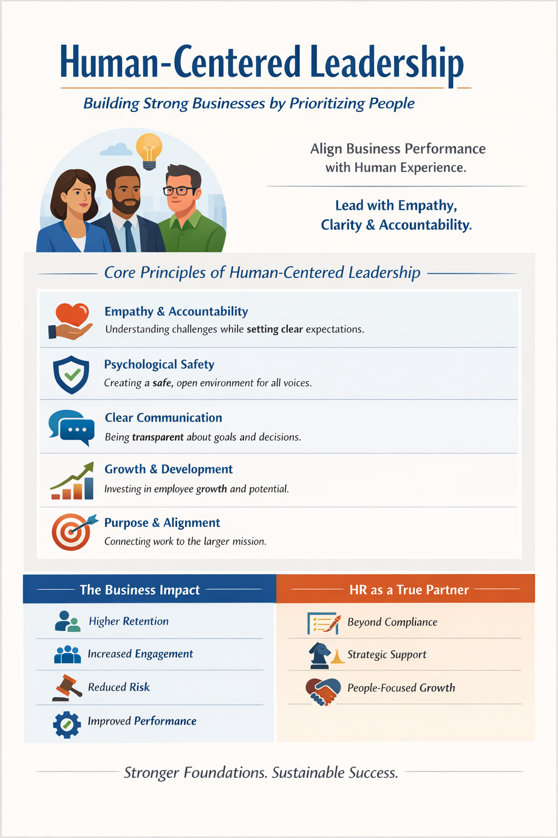HR FOR SMALL BUSINESS OWNERS
A Strategic Framework for Sustainable Growth
If People Drive Your Business, Then People Strategy Drives Your Profit.
This framework helps business owners align performance, protection, and growth in a proactive mode.
The 4 Pillars of Strategic HR
SMART HIRING
Build the Right Foundation
- Clear job descriptions aligned to business goals
- Structured interview process
- Defined performance expectations before hire
- Culture and role alignment
Business Impact:
One bad hire in a 10-person company impacts 10% of your workforce.

CLEAR EXPECTATIONS & ACCOUNTABILITY
Performance Is Managed Not Assumed
- Clearly defined roles and standards
- Regular performance conversations
- Documented coaching and corrective action
- Managers trained to lead, not just supervise
Business Impact:
Avoided conversations turn into costly turnover, disengagement, or claims.
DEVELOPMENT & RETENTION
Protect Your Top Talent
- Structured onboarding
- Leadership training for promoted employees
- Engagement and stay conversations
- Career clarity and growth pathways
Business Impact:
Replacing one employee can cost 30–50% of annual salary.

RISK MANAGEMENT & PROTECTION
Safeguard What You’re Building
- Compliance systems in place
- Consistent documentation practices
- Structured offboarding process
- Clear leave and accommodation procedures
Business Impact:
One preventable claim can cost more than proactive HR systems.
Human-Centered Leadership in Action
Human-centered leadership is not soft leadership.
It means:
✔ Clear standards
✔ Empathy with accountability
✔ Transparent communication
✔ Consistent decision-making
✔ Alignment between people and business goals
Performance and people experience are not opposites they are connected.
Reflections:
- Do I have repeatable people systems or am I reacting?
- Would my documentation protect me in a claim?
- Are my managers equipped to lead?
- Do I have the right people strategy in place or would experienced HR guidance strengthen my growth?
- Are my people systems built for growth or would strategic HR support help me scale more confidently?
- Would my business be better protected with structured HR support in place?
- As my business grows, do I have the HR infrastructure to support it?
Final Thoughts: Having this foundation in place is risk management, performance management, and growth strategy combined.
Strong businesses are built on strong people systems.

