Employee Lifecycle & Financial Impact
Every stage of the employee lifecycle has a direct financial impact on your business. When managed well, HR becomes a growth engine that reduces costs, improves retention, and builds stronger foundations . A strategic HR partner helps you protect your business, develop your team, and scale with confidence aligning people, performance, and business goals.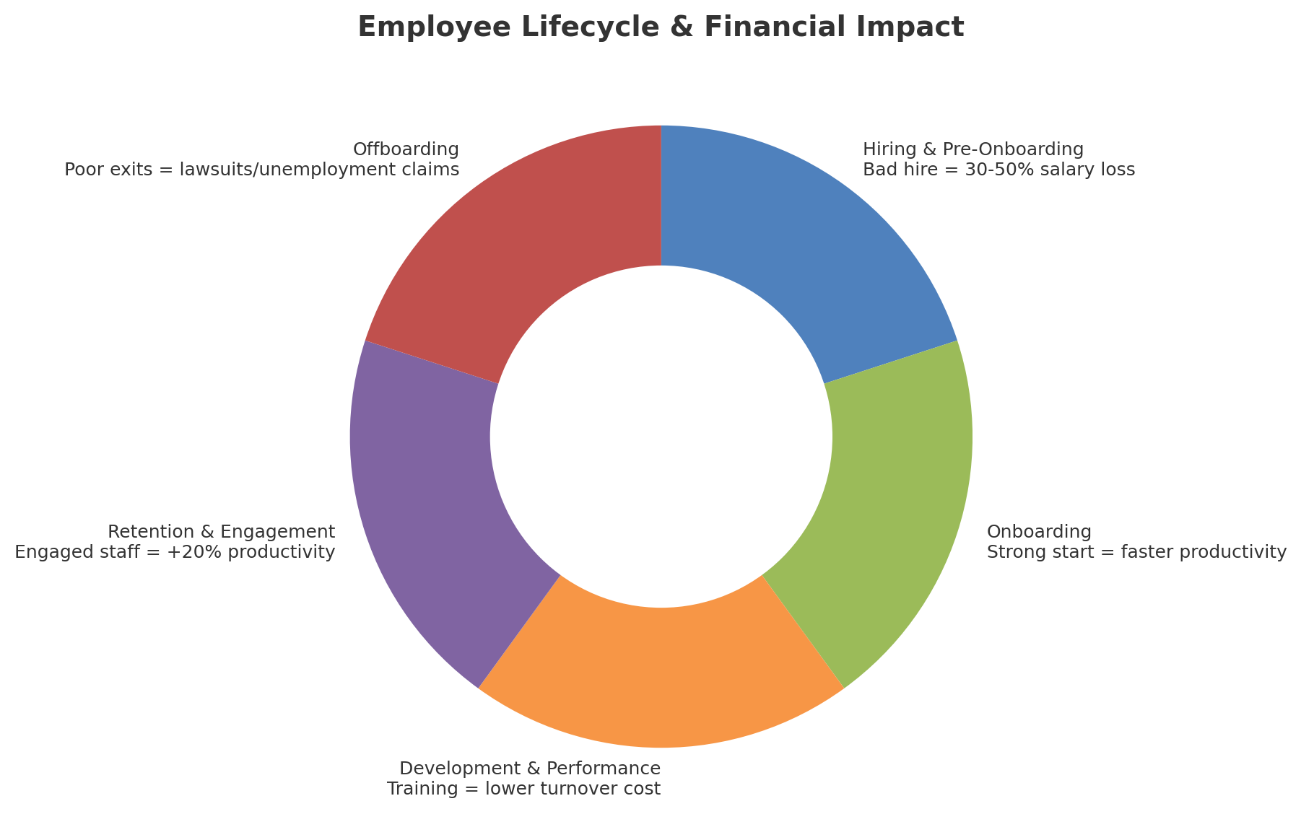

Key Takeaways
• Hiring & Pre-Onboarding: A bad hire costs 30–50% of annual salary. Use clear job descriptions and structured interviews to reduce risks.
• Onboarding: Strong onboarding accelerates productivity and reduces costly mistakes.
• Development & Performance: Training and regular feedback reduce turnover and improve service quality.
• Retention & Engagement: Engaged employees are 20% more productive and strengthen customer loyalty.
• Offboarding: Poorly managed exits can lead to lawsuits, unemployment claims, or reputational damage. Structured offboarding protects your business.

